EWB-REPORT2022-2023

EVENTSCONDUCTEDDURINGYEAR2022-2023

2022-2023

EWB –MJCET student chapter has conducted few events during the academic year 2022-2023.The list of events organized are stated below.
1. Event: WorldWaterDay

Dates:March22,2022

Speaker for the Event: Dr.Ishrat Meera Mirzana
Description: The event focused on the waste water treatment and also for providing solutions to rural areas. More than 50 members registered for theevent.

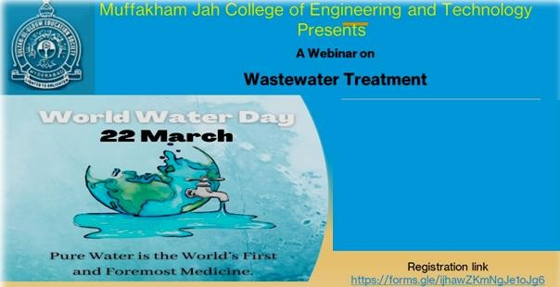

Dr.Ishrat Meera Mirzana,

On

22ndMarch2022

EWB-REPORT2021-2022

2021-2022

2. Event : World Environment Day Awareness Webinar
Date:April5,2022
ModeofEvent:OnlineQuiz

Description:The event was conducted to enrich the the thought process ofEngineersanditfocusedonthevariousproblemsfaced.Totalof26participantshavemembersregisteredfortheevent.
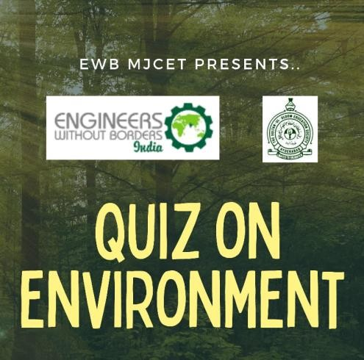

3.Event:PlantationDriveatErramanizilGovt.HighSchool
Dates:April11,2022
ModeofEvent:Offline

EWB-REPORT2021-2022

2021-2022

Description: The event was conducted Govt.HighSchool at Erramnzil the objective of the event was to emphasis the school kids about plantation of trees and to reduce the Global Warming. Total of 25 members have participated in the event.

4.Event : World Environment Day

Date : 5th June 2022

Description :The world environment day is celebrated every year on 5th June to raise global awareness to take positive environmental action to protect nature and the planet earth. It is a day that reminds everyone on the planet to get involved in environment friendly activities.. Keeping this aim in view, EWB-MJCET with EWB-INDIA celebrated World Environment Day on 5th of June 2022. Students of various government high schools participated and celebrated world environmental day enthusiastically. An essay writing competition was held and kids of age group of 7 to 18 years participated. A lot of enthusiasm was seen in the students. The event was conducted successfully with whole hearted participation and awareness about world environment day.
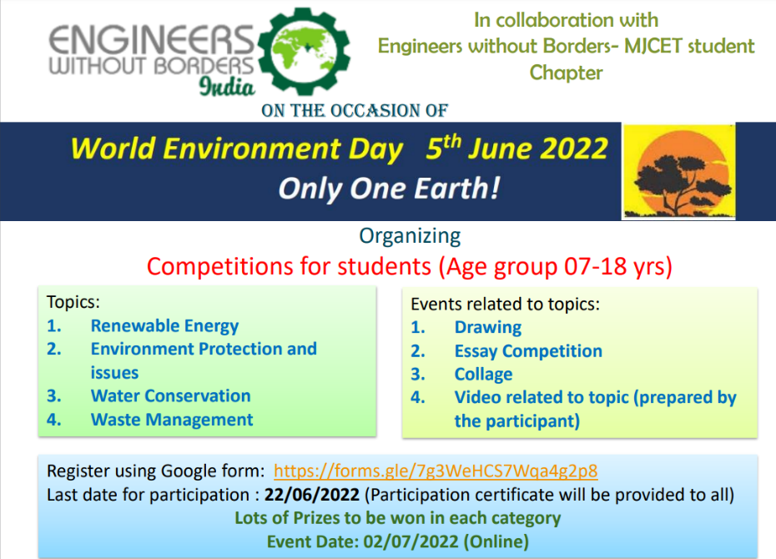

5. Event Name : World Environment Day in Association with MJCET&MGNCRE

Date : 5th JUNE 2022
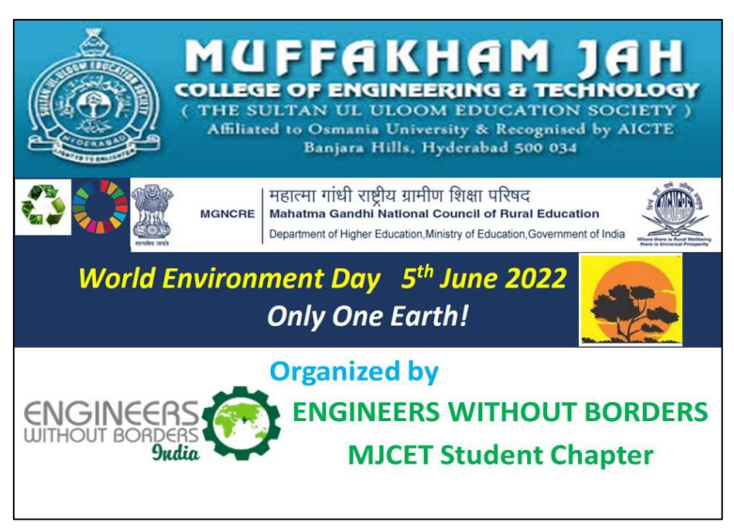

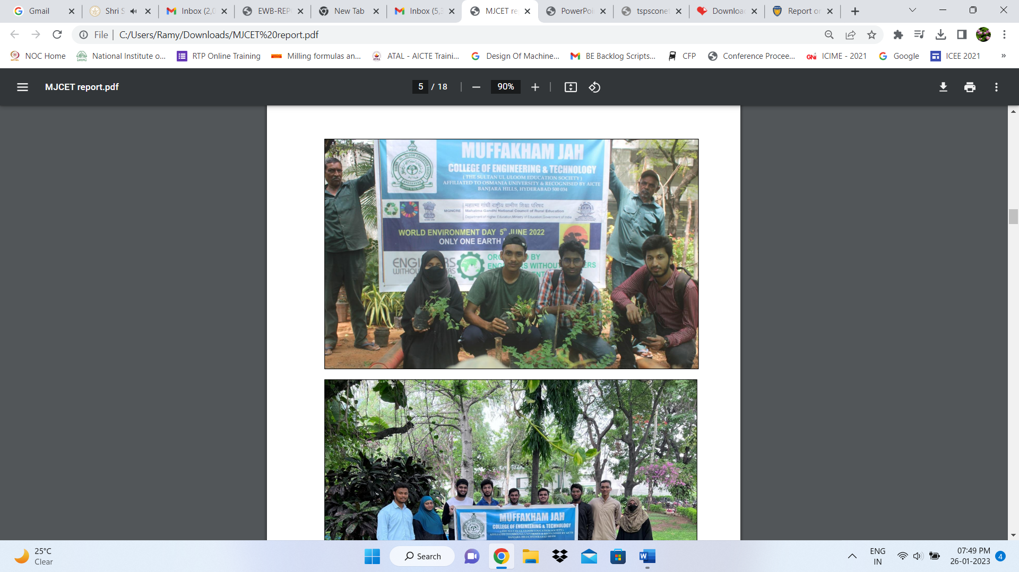
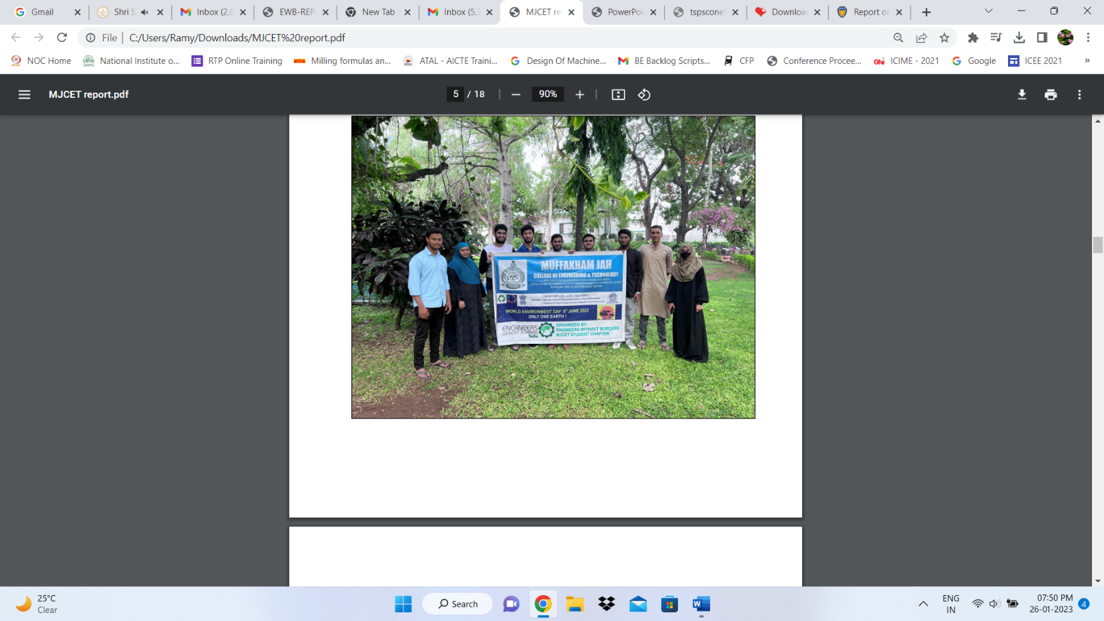

6. Event Name :MEDICAL CAMP AT ADOPTED VILLAGES

Date : 2nd October 2022

Description :Engineers Without Borders MJCET Students Chapter organized Medical Camp on the occasionof Gandhi Jayanthi 2nd October 2022 in association with Lenus Diagnostics Private Limited, Hyderabadwith the support of UBA Cell at the two adopted villages namely Gudi Thanda and Tunikila Thanda,Sangareddy, Telangana state. The main purpose of the camp is to create health awareness among thevillagers to improve their living standards.The medical camp was conducted by the coordinator of Engineers without Borders MJCETStudents Chapter along with the coordinator and members of Unnat Bharat Abhiyaan (UBA) asmentioned in the list given below. With the support of Gram Panchayat members and villagers, the medical camp was successfully completed.
